**6-DOF Manipulator Differential Inverse Kinematics**

**1. Purpose**

In this assignment you will be writing a MATLAB script to calculate a numerical solution to the inverse kinematics problem for the DENSO 6-DOF manipulator. In lab 5, you will be writing a PAC script using this MATLAB code for the DENSO 6-DOF manipulator to pick up a Plexiglas cylinder at a given location and to place it at a second location.

**2. Objectives**

1. Calculate position and orientation geometric Jacobian of the 6DOF manipulator.
2. Implement an inverse differential kinematics algorithm that uses linear position error and quaternion based orientation error.

**3. Requirements**

Demonstrate to the laboratory faculty:

* A working MATLAB script that takes as input a vector of six joint angles $q$ and returns as output the geometric Jacobian $J_{G}(q)$ of the 6DOF manipulator.
* A working MATLAB script that takes as input the end-effector position vector $o_{e}^{b}$ and the minimal representation $ϕ_{e}^{b}$ of the end-effector orientation based on **absolute XYZ rotations**, and returns as output a vector $q$ of the corresponding joint angles. The script must also plot the magnitude of the position and orientation errors as function of the iteration number.

**4. Resources**

The kinematic characteristics of the 6DOF manipulator are:

* Joint limits for the *first revolute* joint $q_{1}$: ± 160°.
* Joint limits for the *second revolute* joint $q_{2}$: ± 120°.
* Joint limits for the *third revolute* joint $q_{3}$: 19°+160°.
* Joint limits for the *fourth revolute* joint $q_{4}$: ± 160°.
* Joint limits for the *fifth revolute* joint $q_{5}$: ± 120°.
* Joint limits for the *sixth revolute* joint $q_{6}$: ± 360°.

The dimensions of the links in $mm$ are given in Figure 1 and Figure 2.

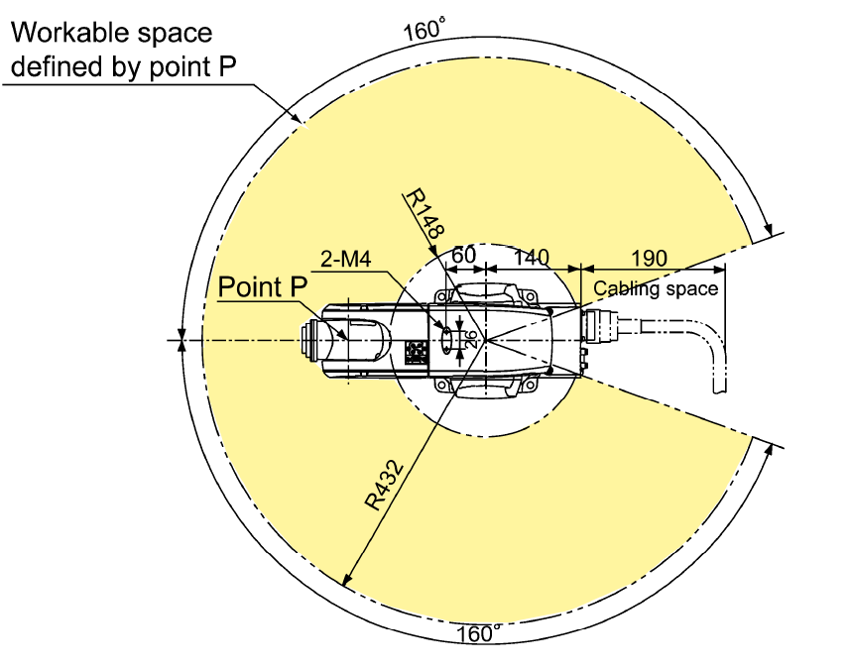

Figure 1: Top View ($q_{3}=90°$).

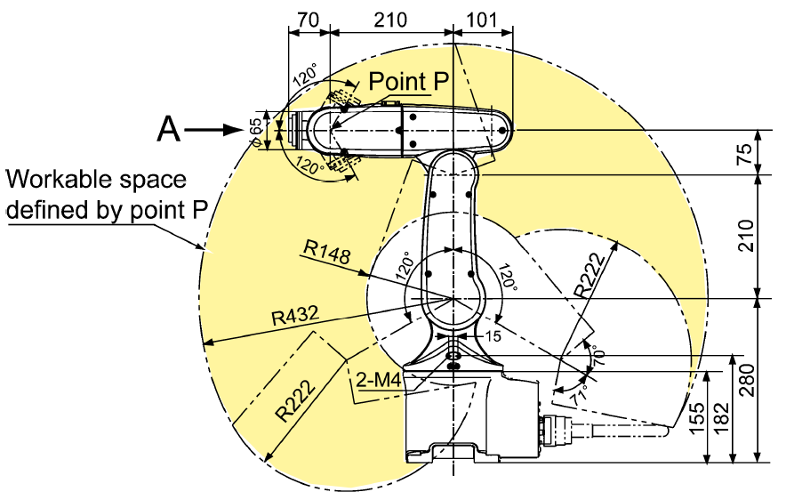

Figure 2: Lateral View ($q_{3}=90°$).

**5. Procedure**

After deriving the Denavit-Hartenberg table for the given manipulator, complete the following three steps.

**Part 1**: Write a MATLAB function J = sixDofJ(q) that takes as input the column vector $q$ containing the values of the six joint angles and returns the (6x6) geometric Jacobian matrix $J_{G}(q)$ of the 6DOF manipulator.

To calculate the geometric Jacobian use the procedure covered in ME302 where you define each column of $J_{G}(q)$ using the rule for revolute joints. Note that in this case your forward kinematics needs to be derived using the Denavit-Hartenberg notation.

If the input vector $q={\left[.9, -.5, .4, -.2, -.8, -1.2\right]}^{T} rad$ is used, then the geometric Jacobian is (**note that all the angles must be in radians for this assignment**!):

|  |  |
| --- | --- |
| $$J=\left[\begin{matrix}\begin{matrix} 189.7140 & 266.8996 & 152.3417 \\ -163.2834 & 336.3358 & 191.9746 \\ 0 & 250.1066 & 149.4273\end{matrix} & \begin{matrix} 32.3803 & 34.0363 & 0 \\ -38.3675 & 27.3042 & 0 \\ -0.9960 & 54.7358 & 0\end{matrix} \\ \begin{matrix}0 & -0.7833 & -0.7833 \\ 0 & 0.6216 & 0.6216 \\ 1 & 0 & 0\end{matrix} & \begin{matrix}-0.0621 & -0.6448 & -0.5897 \\ -0.0782 & 0.7641 & -0.5139 \\ 0.9950 & 0.0198 & 0.6230\end{matrix}\end{matrix}\right]$$ | (5) |

**Part 2:** Write a MATLAB function [o, phi] = sixDofFK(q)that takes the joint values (q) and returns the end-effector position (o) and orientation in absolute X, Y, and Z angles (phi). You can test your code using the following data:

$$q={\left[-0.02, 0.00, 99.99 , 0.02, 0.00, 0.03\right]}^{T} deg$$

$o=\left[\begin{matrix}288.75 \\ -0.11 \\ 515.30\end{matrix}\right] mm$, $ϕ=\left[\begin{matrix}179.70 \\ 80.01 \\ 179.67\end{matrix}\right] deg$

**Part 3**: Write a MATLAB function [q, posErr, oriErr] = sixDofIK(o, phi, q0) that takes as input the desired end-effector position vector $o_{e, d}^{b}$, the minimal representation $ϕ_{e,d}^{b}$ of the end-effector orientation based on **absolute XYZ rotations**, and an initial guess $q_{0}$ for the inverse kinematic solution, and returns as output:

* The vector q containing the six joint variables.
* The vector posErr containing the magnitude of the position error $\left\|e_{P}\right\|$ as function of the iteration number.
* The vector oriErr containing the magnitude of the quaternion based orientation error $\left\|e_{O}\right\|$ as function of the iteration number.

Start testing your implementation with a value $iter_\max{=}100$, and observe the plots of $posErr$ and $oriErr$ vs. iteration to verify if the algorithm is converging or not. You might need to adjust the values $K_{P}$ and $K_{O}$ for fast convergence. A diagonal 3x3 matrix with diagonal entries between 1 to 10 can be a good start. As test inputs use the values of $o_{e, d}^{b}$ and $ϕ_{e,d}^{b}$ calculated for thetest vector $q$ given in Part 1. Notice that the inverse kinematics of a 6DOF manipulator is not unique, and you can have up to 8 different solutions (figures) depending on your choice of $q_{0}$.

The Denavit-Hartenberg table of the 6DOF manipulator is reported in Table 1. Transformations from the base frame to frame 0, and from frame 6 to the end-effector frame are both defined by identity matrices. The forward kinematics can be thus determined using the Denavit-Hartenberg notation.

Table 1: DH table of 6DOF manipulator

|  |  |  |  |  |
| --- | --- | --- | --- | --- |
| **DH** | $$d_{i}$$ | $$ϑ_{i}$$ | $$a_{i}$$ | $$α_{i}$$ |
| 1 | $$280$$ | $$q_{1}-π$$ | $$0$$ | $$π/2$$ |
| 2 | $$0$$ | $$q_{2}+π/2$$ | $$210$$ | $$0$$ |
| 3 | $$0$$ | $$q_{3}-π/2$$ | $$75$$ | $$-π/2$$ |
| 4 | $$210$$ | $$q_{4}$$ | $$0$$ | $$π/2$$ |
| 5 | $$0$$ | $$q_{5}-π$$ | $$0$$ | $$π/2$$ |
| 6 | $$70$$ | $$q_{6}$$ | $$0$$ | $$0$$ |

The pseudo code of the inverse differential kinematics algorithm is provided in Figure 3.

differential_inverse_kinematics

Input: $o_{e, d}^{b}$, desired position

$ϕ_{e,d}^{b}$, desired orientation based on absolute XYZ rotations

$iter_max$, maximum number of attempts for the solver

Ouput: $q_{d}$, set of desired configurations

$q←q_{0}$

1. convert $ϕ_{e,d}^{b}$ into $\left\{η_{e,d}^{b},ε_{e,d}^{b}\right\}$
2. **For $i=1$**  **to $iter_max$**  **do**
3. calculate $o_{e}^{b}(q)$ and $\left\{η_{e}^{b}(q),ε_{e}^{b}(q)\right\}$
4. calculate $J_{G}\left(q\right)$


$e_{P}←o_{e, d}^{b}-o_{e}^{b}(q)$

${\tilde{e}}_{O}←{-η_{e,d}^{b} ∙ε}_{e}^{b}\left(q\right)+η_{e}^{b}\left(q\right){∙ε}_{e,d}^{b}-ε_{e,d}^{b}×ε_{e}^{b}(q)$

$q←q+∆t ∙\left( J_{G}{\left(q\right)}^{-1} ∙\left(\left[\begin{matrix}{\dot{o}}_{e}^{b} \\ ω_{e}^{b}\end{matrix}\right]+\left[\begin{matrix}K_{P} & 0 \\ 0 & K_{O}\end{matrix}\right]∙\left[\begin{matrix}e_{P} \\ {\tilde{e}}_{O}\end{matrix}\right]\right)\right)$

8. **If $\left\|e_{P}\right\|<{10}^{-4}$**  **and $\left\|{\tilde{e}}_{O}\right\|<{10}^{-4}$**  **then**
$q_{d}←q$

10. **return $q_{d}$**
11. **end if**
12. **end** **for**

Figure 3: Differential inverse kinematics pseudo code.

**6. Deliverables:**

In a zipped folder named with your first and last name and the lab number, include the following items and submit on canvas under assignments/lab report 4.

1. Lab report in pdf.
2. Working MATLAB codes that performs the tasks illustrated in parts 1 and 2 of the Procedure Section.